Add Students – Manually
Student data can be added by school or district through an import process by a Manager.
All student data is associated with the student’s ID number. This allows students to be placed in more than one classroom for multiple teachers to review data, for the student to easily transfer between campuses, or for the student to be removed without any data being lost.
It is necessary to be logged onto the Reports and Management Web site to complete this.
- After logging in, select the classroom where students are to be added in the My Classroom Management section at the bottom of the page.
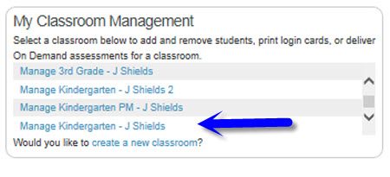
- Select either of the options for adding students in the Manage Classroom section. The option in the blue box will be available to add additional students later.
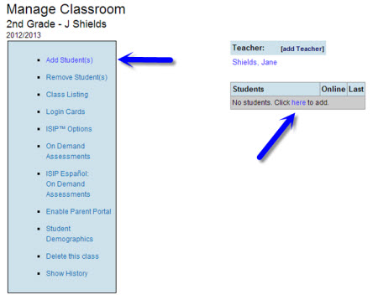
- Select the Student ID field and enter the student’s unique district-assigned student ID number (PEIMS, Skyward, etc.).
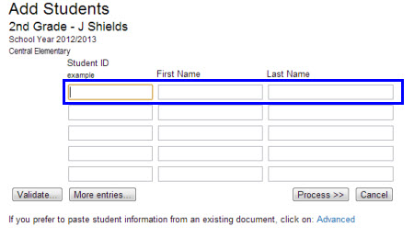
- Press the Tab key to move to the First Name and Last Name fields to complete those with the student’s district-recognized name.
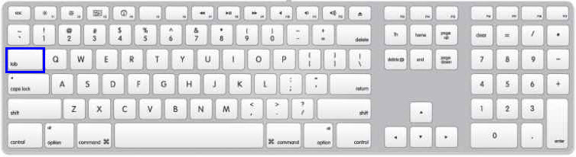
- Press the Tab key to move to the next line for adding additional students.
- If there are more than five students to add, select the More entries… button at the bottom of the screen to add more lines.
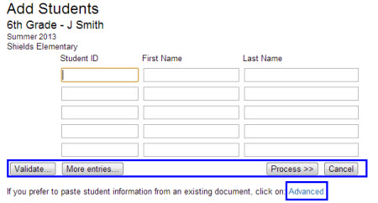
- The Validate… button verifies that the ID number matches the student ID format for the school.
- Click Process>> to finish adding students to the classroom.
- If the student information conflicts with information currently in the system because of the ID number already being in use in the district, similar student name, or a user name conflict within the school, you will see a screen that indicates Istation has not been able to complete the addition.
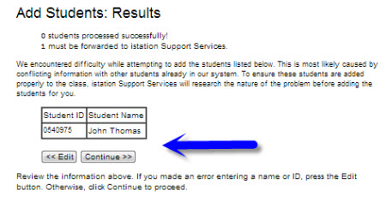
- At this point, using the << Edit option allows the user to return to the data entered previously and make corrections. If unaware of the issue, the user may click on Continue >> to send the information to Istation Support Services for help.
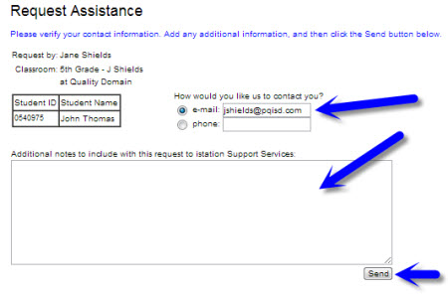
- On the following screen, verify email address, include any important information that Istation Support Services might need to know, and press click Send.
- When Istation Support Services receives the conflict, support will review it and may make contact by email to verify correct information for the student(s) involved. Upon receiving a response verifying the information, the student will be added by Istation Support Services.

TIPS:
If a student is changing classrooms at a school, the student’s password can remain the same if the student is added to the new classroom using these instructions before removal from the previous classroom using the Manually Removing Students instructions.
If all student data is in a typed spreadsheet or document, you can copy and paste this information by using the Advanced link at the bottom of the screen. This is ideal if only adding a single classroom. If the entire school’s students need to be added, a manager should use the Import Process.
- To use the Advanced option, copy the data from a spreadsheet or document and paste it into the blank field.
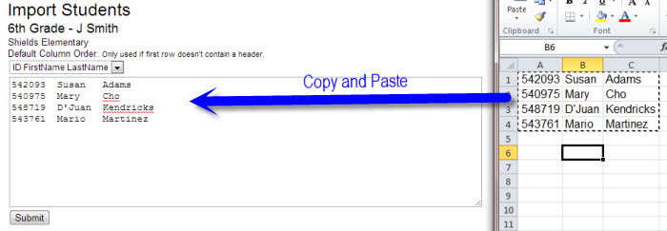
- Select the correct order of the listed student information from the drop-down menu.
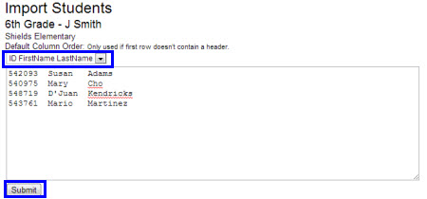
- Click the Submit button to finalize the student additions.

