ISIP Summary
- This report shows the number and percentage of students in the classroom at each instructional tier, for each skill assessed, during the current assessment period.
- Individual student results are listed in the table underneath the graph. Students are grouped by risk level.
- Instructional tiers are displayed for overall reading and for each skill assessed
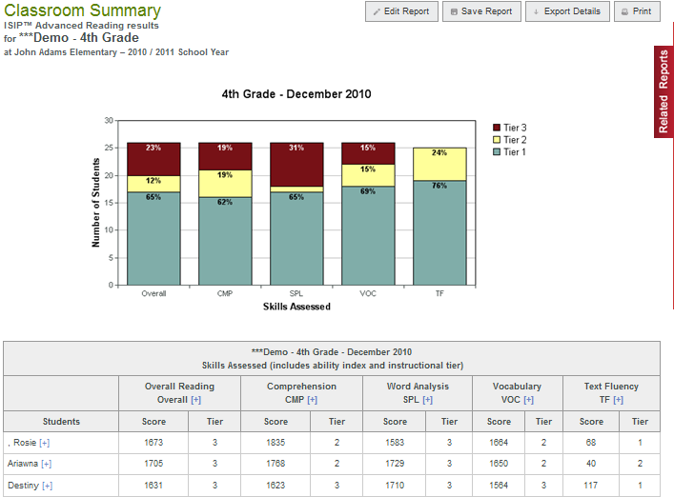

By clicking the “plus” sign by a student’s name you will get the ISIP Summary History. This shows all the assessments taken.

HOW TO RUN THE CLASSROOM ISIP SUMMARY
- Log on to website: www.istation.com

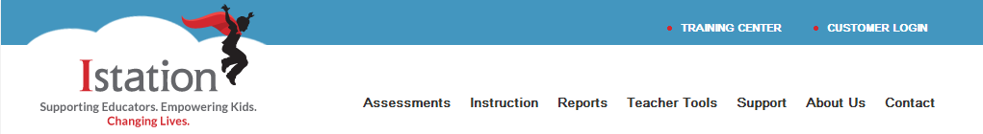

- Click “Report Tab”

- In the “Products” section select ISIP Early or ISIP Advanced for products
- In the “Reports” area select Summary for reports
- In the “Selected Reports” area click “Run Selected Report” for the report to run for the current month OR select “Customize Report” to further customize the report to run in a previous month or to adjust features

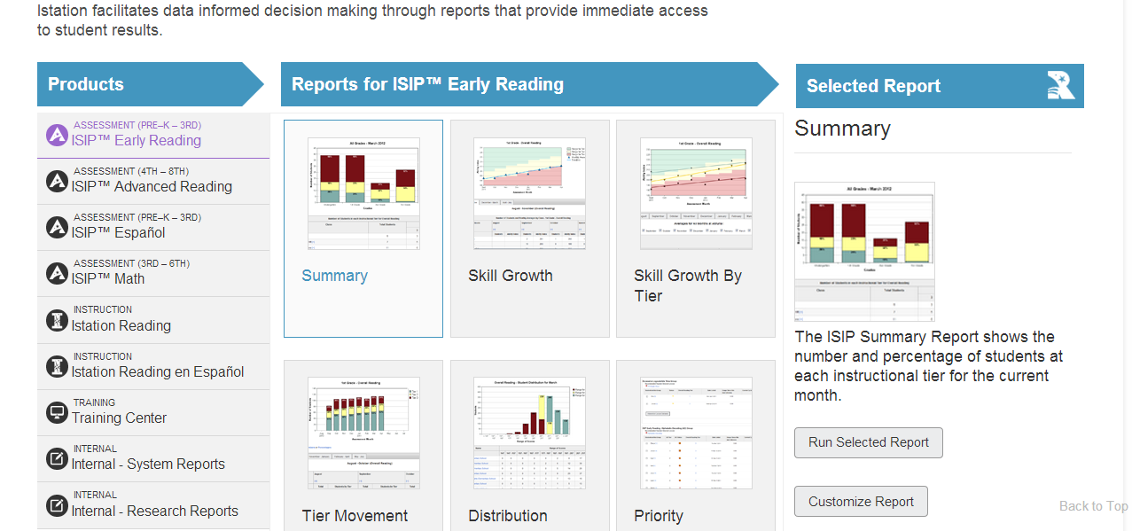
Suggested Uses for Instructional Purposes
- Identify skills that need to be emphasized in the classroom.
- Identify students in need of additional support.
- Group students for targeted instruction.

