Istation Reading Progress Report
This report shows student progress through the Istation Reading Program's cycles of instruction by reading areas.
Students are placed in a cycle of instruction based on initial ISIP™ Assessment results. No instruction was needed in the cycles marked with blue arrows.
- Moving forward in the cycles is based on activities completed by the student while working in the Istation instruction.
- Marked improvement in a new ISIP Assessment can cause a student to accelerate through the cycles or skip ahead cycles in the instruction.

How to Run the Progress Report
It is necessary to be logged into the Reports and Management Web site (www.istation.com) to complete this. For instructions on logging in, click here.
- After clicking the Report tab, select Istation Reading or Istation Reading en Español from the Products list, and then choose Progress from the Reports list. Next, click the Customize button.
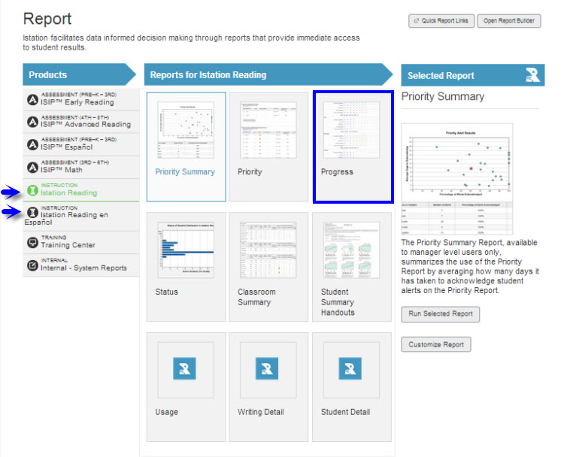

- Under the Options tab, select the desired school year.
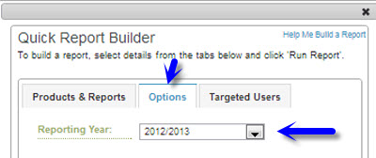

- Under the Targeted Users tab, select the classroom to view. Do not select an option in the Student Groups drop down menu. Click Run Report.
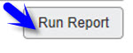
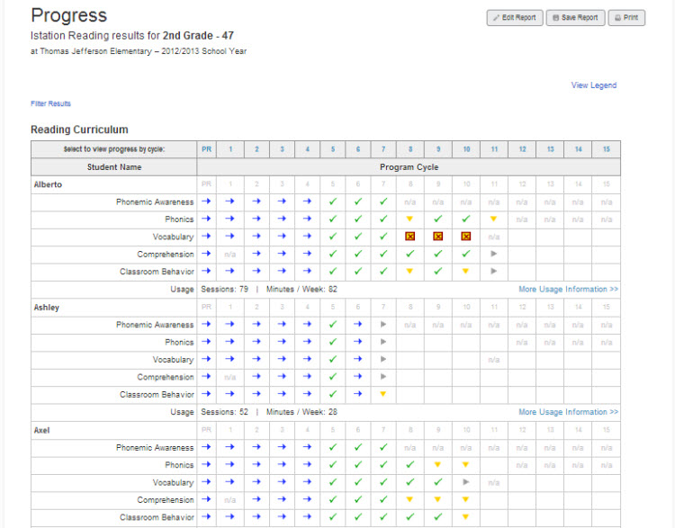
Results may be filtered by skill. Click on Filter Results and check the box for the desired skills. The results are listed under each student’s name.
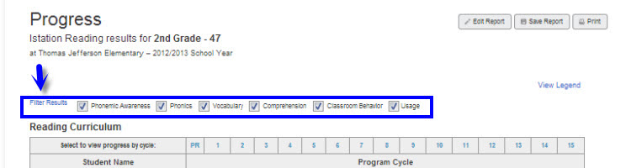
- Progress is color-coded to provide an understanding of how students are performing within each cycle and reading area at a glance.
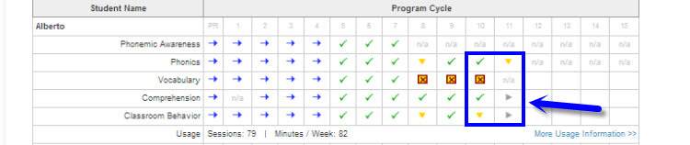

- The symbol legend is available by clicking on View Legend.
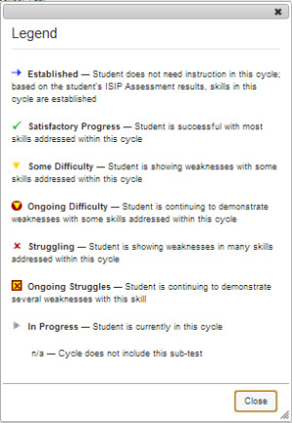

- Clicking the More Usage Information>> link opens the student’s Session Summary and Activity Detail.
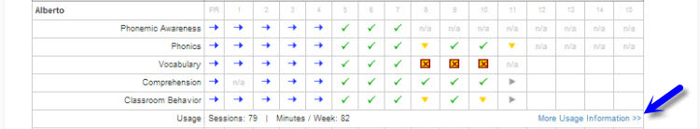

Suggestions for Instructional Purposes:
- Monitor student movement and performance through cycles of instruction.
- Identify student skill strengths and weaknesses.
- Discuss student performance with administrators and intervention teams.

