Istation Reading Student Detail Report
This report displays information about student performance by skill.
- Each skill is broken down into specific activities where the student received instruction.
- Clicking on available tabs provides further detailed information for specific skills.

How to Run the Istation Reading Student Detail Report
It is necessary to be logged into the Reports and Management Web site (www.istation.com) to complete this. For instructions on logging in, click here.
- After clicking the Report tab, select Istation Reading or Istation Reading en Español from the Products list, and then choose Progress from the Reports list. Next, click the Customize button.
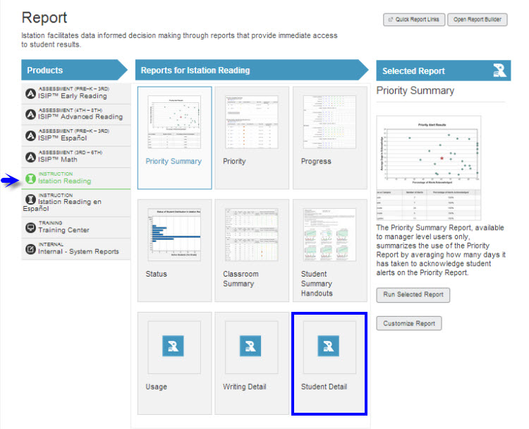
- Under the Options tab, select the desired school year and skill.
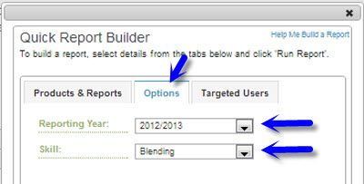

- Under Targeted Users, select student(s) and click Run Report. (This is a student level only report.)
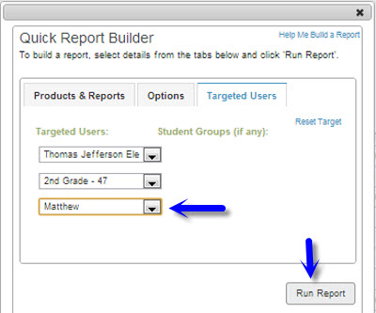

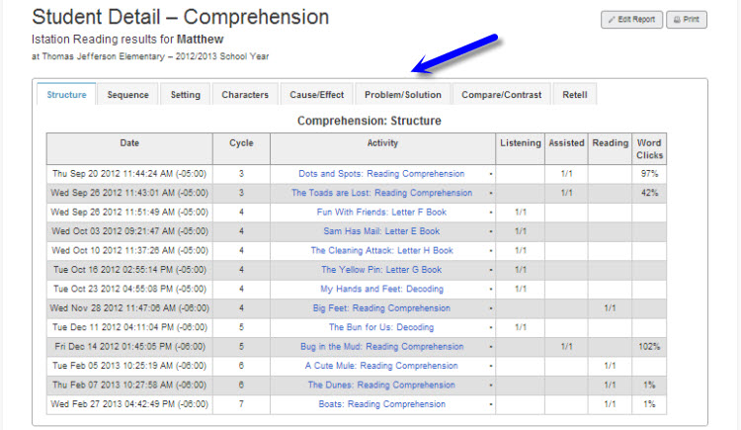

Suggestions for Instructional Purposes:
- Monitor student progress on the Interactive Instruction.
- Assist with specific skill instruction.

Frequency of Review:
Weekly or biweekly for small group instruction

