ISIP Skill Growth Report
This report shows Overall Reading assessed and progress made by the class through the current month.
- The graph represents average student performance for the class.
- The ability index for each student is presented in the table below the graph.
- The graph represents a measure of growth over the entire school year.
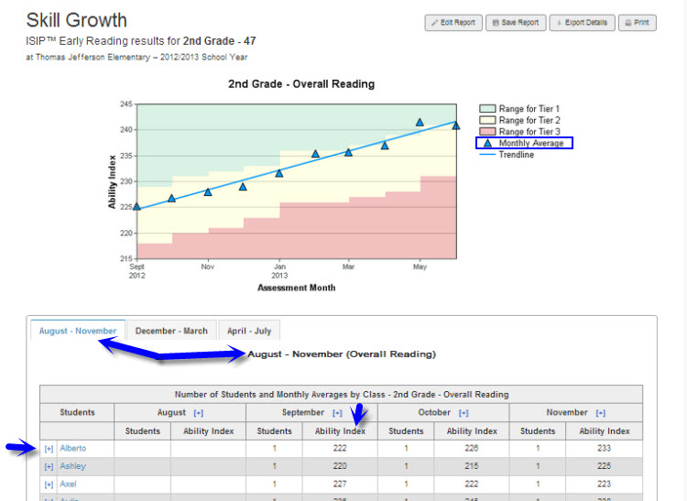

Suggested Uses for Instructional Purposes:
- Monitor the class’s progress in skill acquisition.
- Evaluate effectiveness of instructional support.
- Determine the need for whole group instruction.
Frequency of Review
Monthly or after most recent assessment

How to Run the ISIP Skill Growth Report
It is necessary to be logged into the Reports and Management Web site (www.istation.com) to complete this. For instructions on logging in, click here.
- After clicking the Report tab, select ISIP™ Early Reading, ISIP™ Advanced Reading, or ISIP™ Español from the Products list, and then choose Skill Growth from the Reports list. Next, click the Customize button.
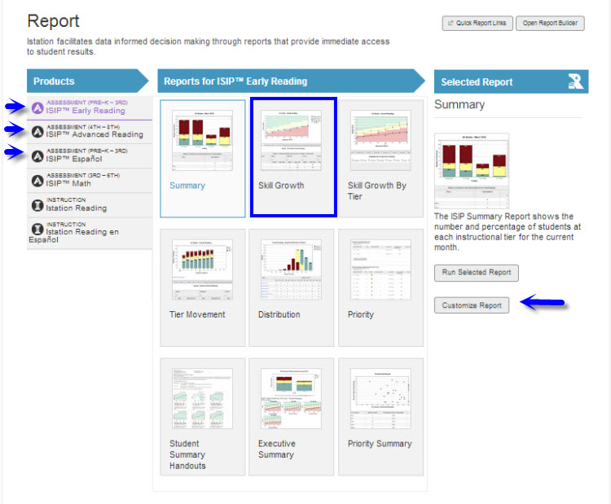
- Under the Options tab, select the desired school year and skill. It is necessary to select a grade level if the classroom to view is a multi-grade class.
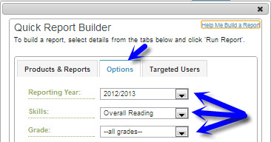
- Under the Targeted Users tab, select the classroom to view. Do not select an option in the Student Groups drop down menu. Click Run Report.
