ISIP Tier Movement Report
This report shows the percentage and number of students in each tier by month.
Individual student tier movement is presented in the table below the graph.
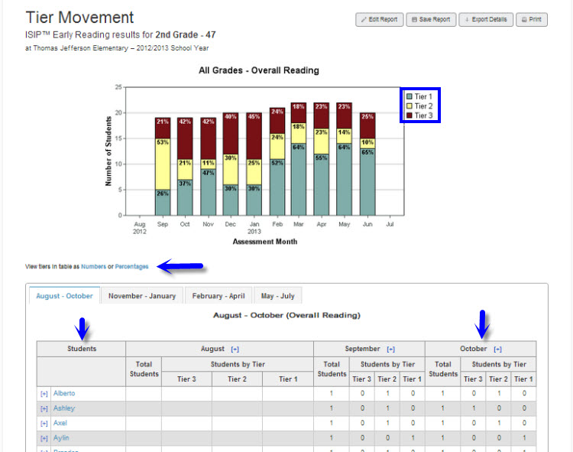

Suggested Instructional Purposes:
- Evaluate student growth through the school year.
- Evaluate effectiveness of instructional support.
- Monitor for increase of Tier 1 students and decrease of Tier 2 and Tier 3 students.

Frequency of Review:
Monthly or after most recent assessment

How to Run the ISIP Tier Movement Report
It is necessary to be logged into the Reports and Management Web site (www.istation.com) to complete this. For instructions on logging in, click here.
- After clicking the Report tab, select ISIP™ Early Reading, ISIP™ Advanced Reading, or ISIP™ Español from the Products list, and then choose Tier Movement from the Reports list. Next, click the Customize button.
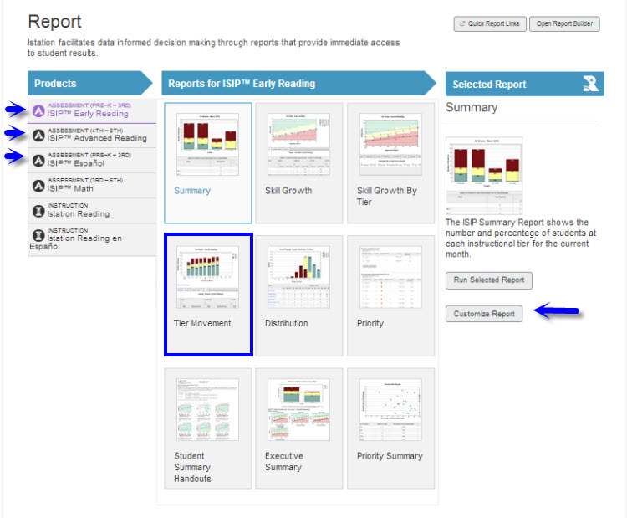

- Under the Options tab, select the desired school year and skill.
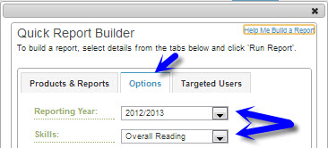

- Under the Targeted Users tab, select the classroom to view. Do not select an option in the Student Groups drop down menu. Click Run Report.
