Istation at Home – Enabling the Parent Portal
Teachers must provide login information to the parents or guardians of students. Here are the instructions on how to provide login information.
It is necessary to be logged onto the Reports and Management Web site to complete this.
- On the Report and Management Web Site, select a classroom in the Istation Home box.
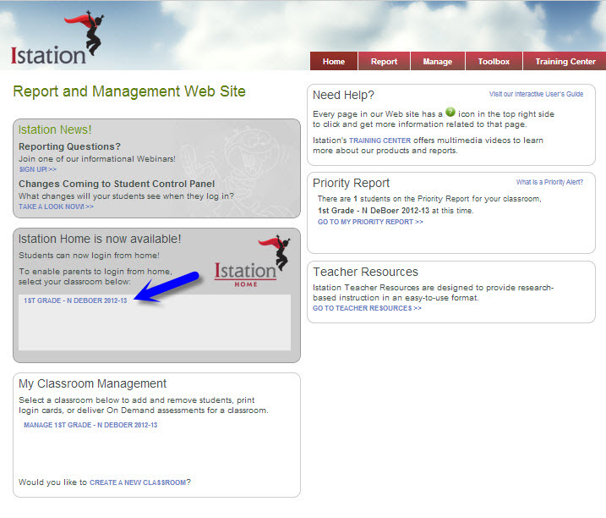
- Choose Select All or select individual students listed to enable parents to log in to the Istation Parent Portal Web site from home to see limited reports and resources using their student’s Istation account.
- Click Update.
- Then click on PRINT A LETTER FOR STUDENTS TO TAKE HOME TO THEIR PARENTS.
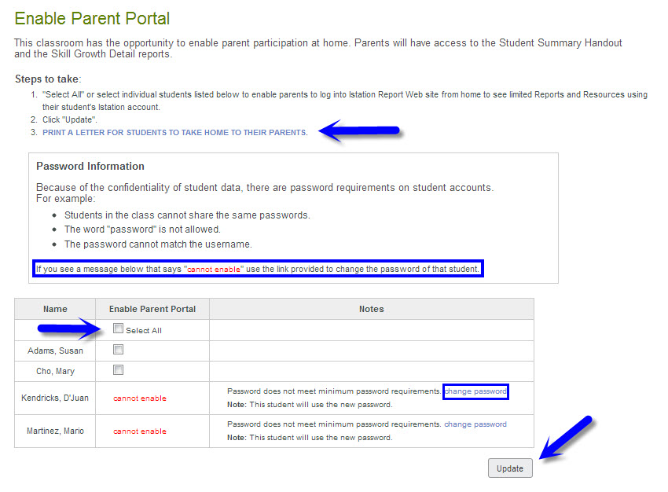
NOTE: If the message “cannot enable” appears, then the password does not meet the minimum requirements. To change the student’s password, please click the change password link provided.
- Print out the Istation Home Login Information and distribute to students for them to take home to their parents/guardians.
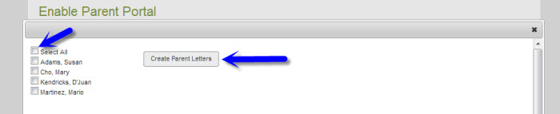

For any assistance or information, please contact Istation Support Services at 866-883-7323, ext. 2 from 7:30 a.m. to 6:30 p.m. (CT) Monday through Friday, or email support@istation.com.

