Priority Report
- This helps identifies students who will benefit from further intervention and provides links to teacher-directed lessons and supplemental materials.
- Students are listed if they have demonstrated weaknesses on an ISIP Assessment or lack of progress in skill acquisition in the Interactive Instruction
- Students are grouped by skill to facilitate whole- or small-group instruction. A student history of identified skill weaknesses and interventions is retained.
- Students will also be identified if they demonstrate excessive logouts and idle time.
- Click on the link under Recommended Teacher-Directed Lessons to access the recommended intervention.
- After administering the intervention, select the checkbox next to the student’s name, and click Intervention Lesson Delivered to remove the student from the list.
- Clicking this button will also document when a student has been given teacher-directed intervention.
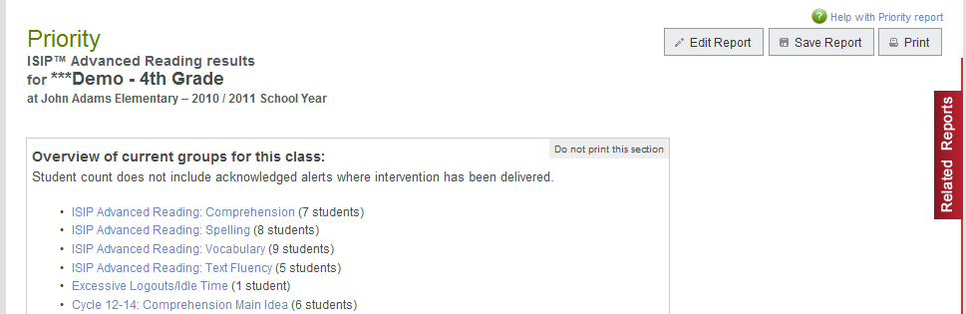
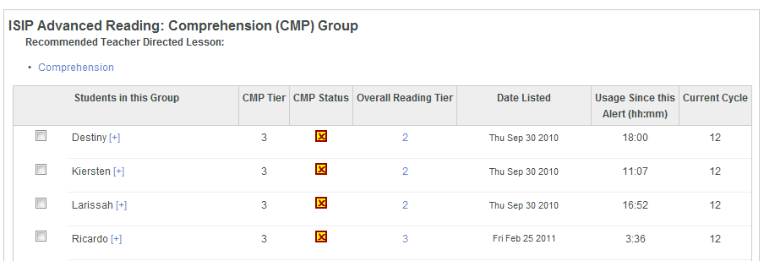

- Log on to website: www.istation.com
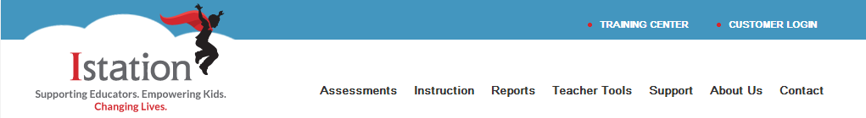

- Click “Report Tab”

- In the “Products” section select ISIP Early or ISIP Advanced for products
- In the “Reports” area select Priority for reports
- In the “Selected Reports” area click “Run Selected Report” for the report to run for the current month OR select “Customize Report” to further customize the report if you are in a leadership role and need to choose a particular classroom to view

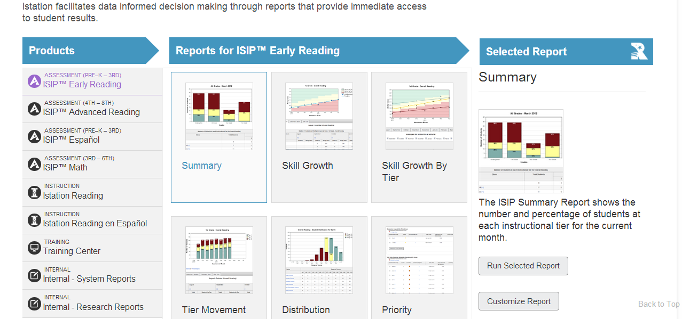

- IF YOU ARE FURTHER CUSTOMIZING THIS REPORT- HERE ARE SOME GUIDELINES
- “Products and Reports” tab select ISIP Early or ISIP Advanced for products (first pull down)
- Select Priority for reports (second pull down)
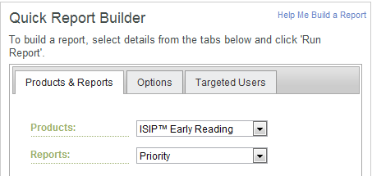
- “Options ” tab select desired option

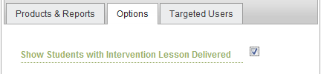

When you select “Show Students with Intervention Lesson Delivered, this will show ALL students who have DOCUMENTED INTERVENTIONS and students STILL IN NEED of intervention
- “Target Users” select “all” OR if a leadership level, determine which class to view and click “Run Report”

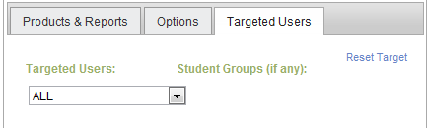

Use this report to:
- Select students for small group instruction and obtain teacher-directed lessons and materials.
- Document interventions provided.
- Monitor student performance.
- Discuss student performance with administrators or intervention team

