PRIORITY SUMMARY REPORT

- The Priority Summary Report, available to manager level users only
- Summarizes the use of the Priority Report
  - Total number of alerts per class
  - Percentage of alerts acknowledge on the Priority Report
  - Average number of days it has taken to acknowledge alerts on the Priority Report.
- Individual classes are listed in the table underneath the graph
- Hovering over a gray dot, gives individual class information

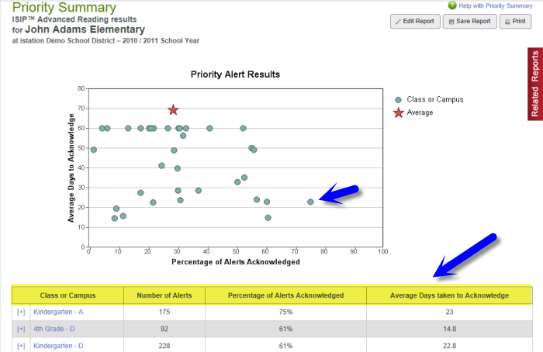

HOW TO RUN THE PRIORITY SUMMARY REPORT

Log on to website: www.istation.com
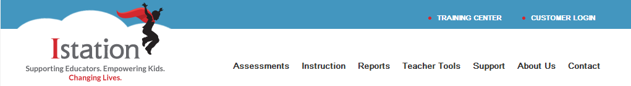

Click “Report Tab”

- In the “Products” section select ISIP Early or ISIP Advanced for products
- In the “Reports” area select Priority Summary for reports
- In the “Selected Reports” area click “Run Selected Report” for the report to run for the current month OR select “Customize Report” to further customize the report if you are in a leadership role and need to choose a particular classroom to view

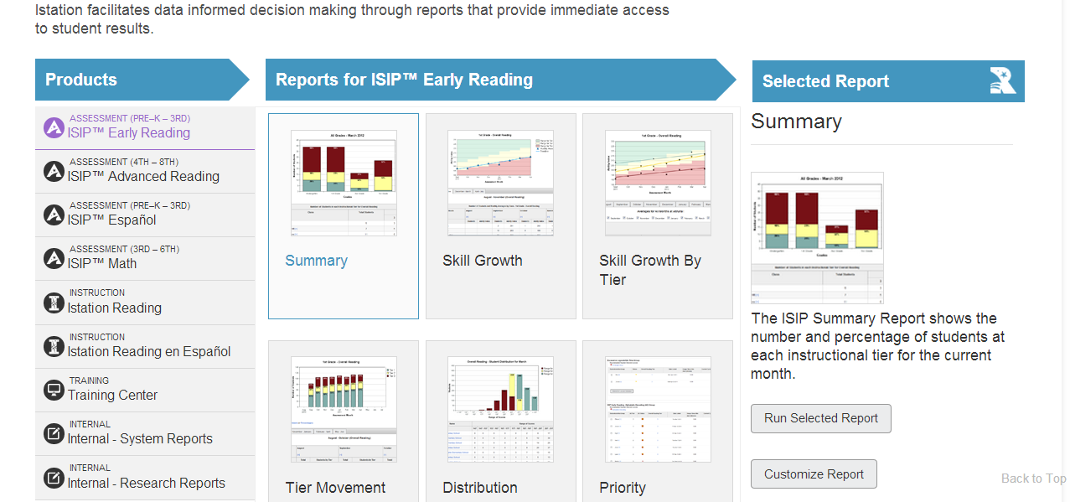

If CUSTOMIZING THE REPORT, the Report Builder will appear.

“Options ” tab select allows for selection of the desired school year and either last 45 days or entire school year.

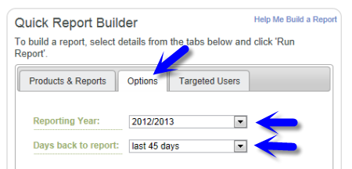

“Targeted Users” allows for selection of “all” or a targeted group and then click “Run Report”

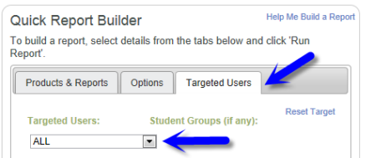
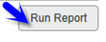

BE SURE TO SAVE YOUR QUICK REPORT LINK IF DESIRED TO ACCESS THIS REPORT MORE READILY THROUGHOUT THE YEAR.

Remember more detailed information can be accessed on any report by clicking the blue plus sign, student’s name, or blue text.

