Remove Students – Manually
To help preserve historical data about classrooms and schools, student accounts should NOT be removed at the end of the school year.
All student data is associated with the student’s ID number. This allows students to be removed and re-added without any data being lost.
Students who are added to another school in the district will automatically be removed from the original school.
It is necessary to be logged onto the Reports and Management Web site to complete this.
- After logging in, select the classroom where students are to be removed in the My Classroom Management section at the bottom of the page.
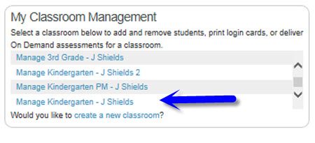
- Select Remove Student(s) from the blue box.
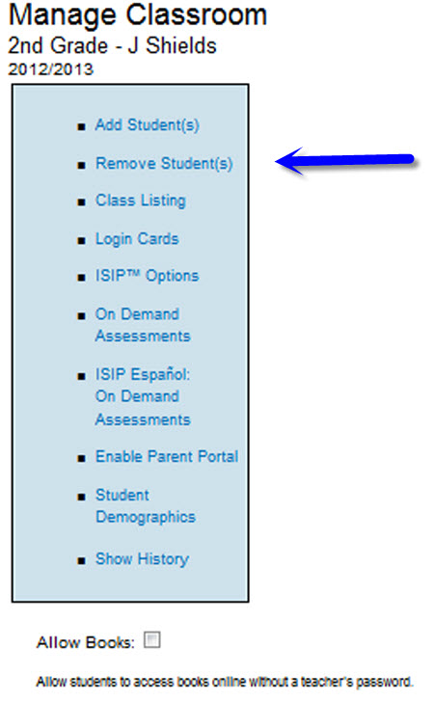
- Select the checkbox(es) in front of the student(s) to be removed.
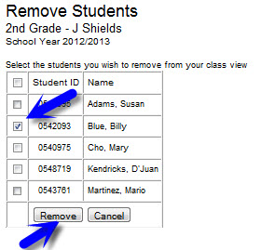
- Click the Remove button to complete the process.

