Student Summary Handout

This customizable report provides a summary of students’ performance for the current school year.
Available information includes:
- Program Overview - includes cycle of instruction, last date of use and program usage.
- *The Lexile range listed represents the Lexile levels of books the student has experienced in their current instructional cycle of the Istation Reading program.
- Priority Overview - includes all priority report alerts
- ISIP Percentile Rank - better than or equal to x% of students who took this test at the same time
- ISIP Grade Equivalency - performing as an average student in a specific grade who took this test in a given month.
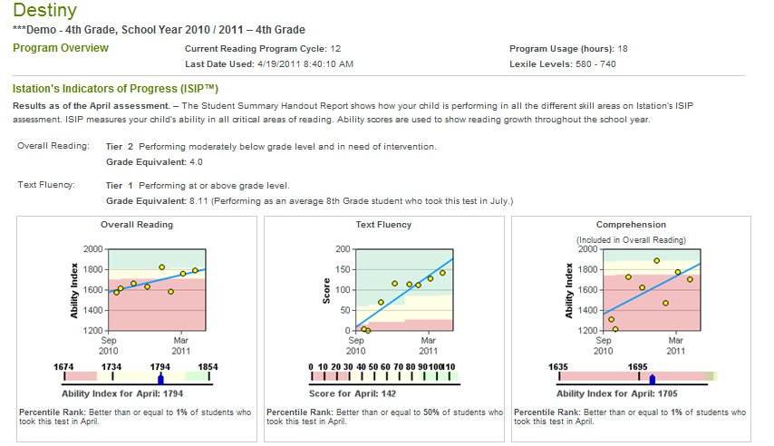

- Log on to website: www.istation.com

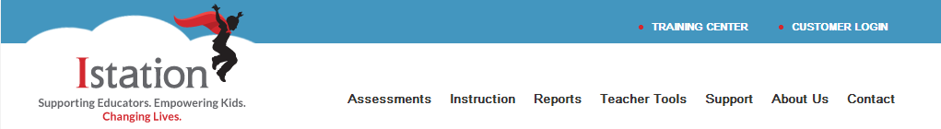

- Click “Report Tab”

- In the “Products” section select ISIP Early or ISIP Advanced for products
- In the “Reports” area select Student Summary Handouts for reports
- In the “Selected Reports” area click “Run Selected Report” for the report to run for the current month OR select “Customize Report” to further customize the report to choose specific students and language.

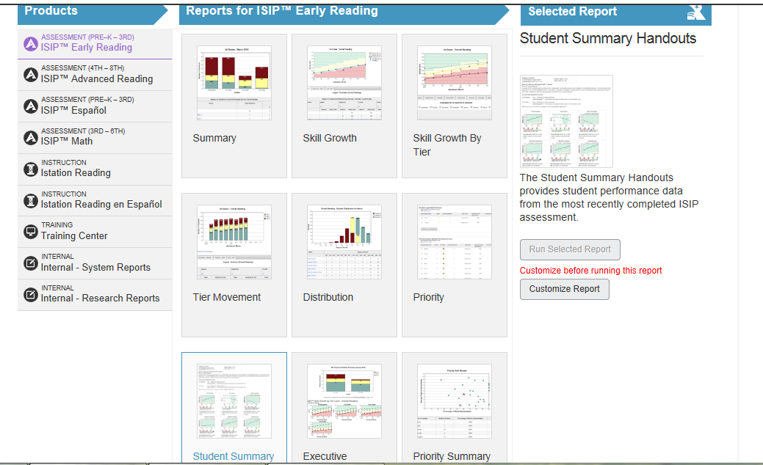

- If “Customize Report” is chosen, the Report Builder will appear with additional features.
- “Options ” tab select desired option

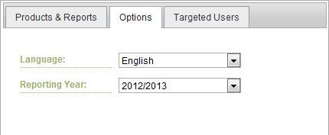
This report has the option for English or Spanish.

- “Target Users” select “all” and click “Run Report”

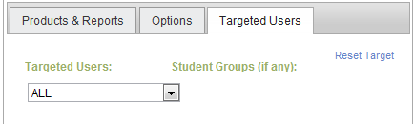
You can choose “all” or select specific students by name.

Use this report to:
- Evaluate the student’s intervention plan.
- Identify student’s skill weaknesses.
- Discuss student’s performance with administrators and intervention teams.
- Print to use and plan for Parent/Teacher conferences.

Can be used for RtI committee meetings
By clicking on a subtest, any documented interventions will be indicated by a RED vertical line
Documentation for interventions are listed below with the date and name of person documented
Report can be printed without the documented interventions
Report can be printed in English or Spanish

