Teacher Station
- Resource available to teachers/managers to assist with instruction
- Provides virtual, interactive lessons
- Uses whole group, small group, or individual instruction based on teacher preference
- Provides engaging cross-curricular activities

Teachers and Managers can access Teacher Station by following these steps.
- Click the Istation icon.
- Enter teacher/manager user name and password and click OK. (Your domain will be specific to your location by campus or district and will not say “Istation.”)
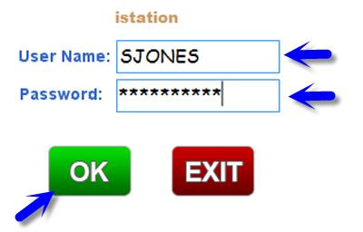
- The menu below will appear, displaying products your campus and district have within their subscriptions. Only teachers and managers will see Teacher Station, not students.
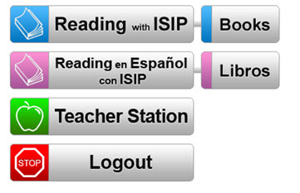
- The Reading with ISIP and the Reading en Español con ISIP buttons allow teachers/managers to participate in ISIP Assessments and Interactive Instruction.
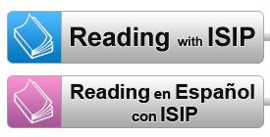

- The Books and Libros buttons allows some books to be interactive. When projected, these can be used as whole group texts to practice a specific skill. Students can be provided with a hard copy of the text as well.
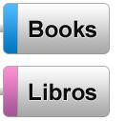
- The Teacher Station button has a wealth of cross curricula activities from which to choose. Each button leads to detailed information and lessons. These lessons can be used to supplement the curriculum in a variety of ways.
  - mini lessons
  - reteach lessons
  - computer activity during work station time
  - small group
  - partner activities

